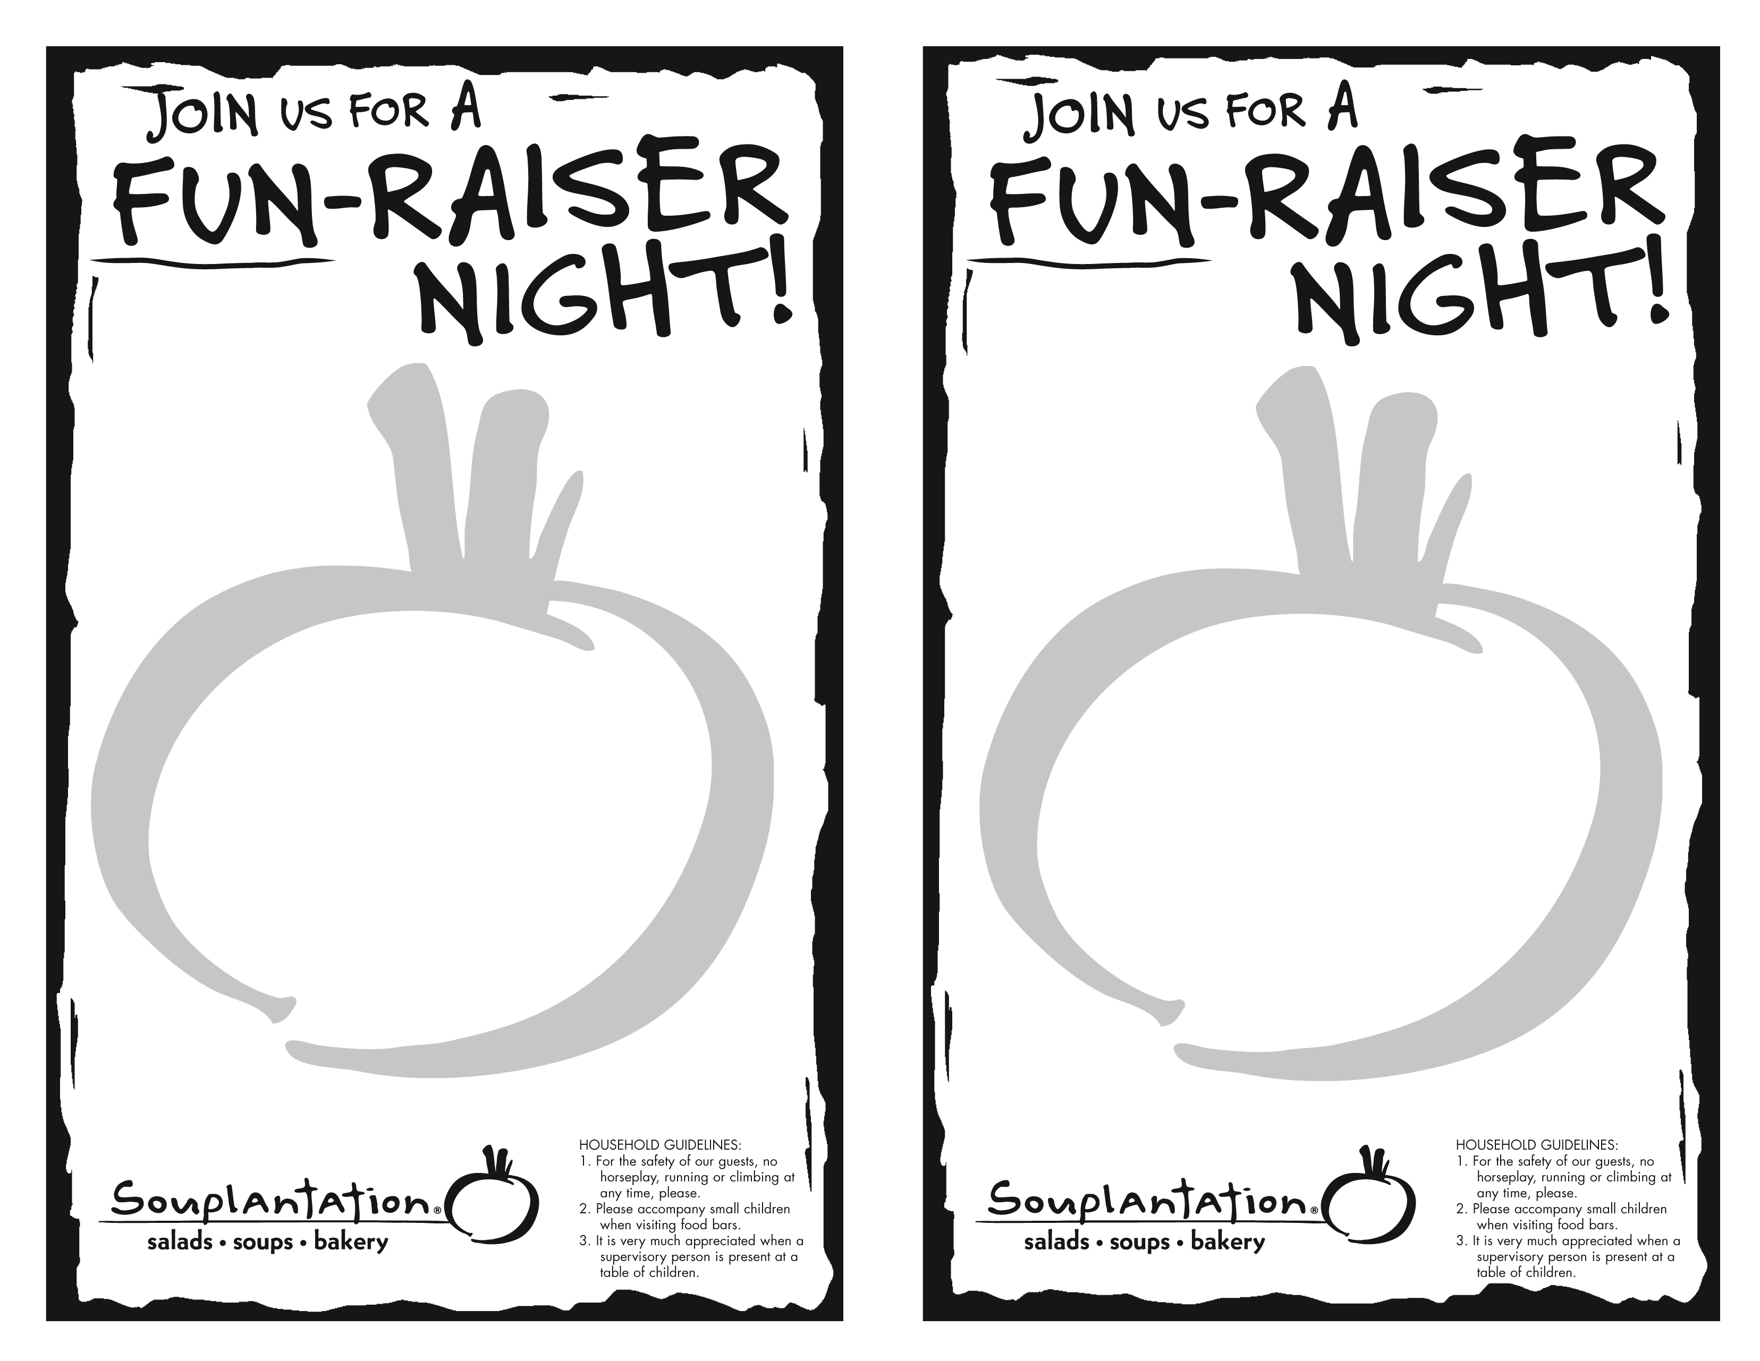

Benefiting

Chatsworth High School Cheer

What’s The Deal?
Souplantation will donate 15% of sales generated by Chatsworth High School Cheer!

What To Do:
Present this flyer between 5:00 pm and 8:00 pm on Wednesday, March 21, 2007, purchase a meal and a beverage* and enjoy a great meal and help a great organization!

Where To Do It:
At the Souplantation only, located at: 19801 Rinaldi Street, Northridge 818-363-3027

Every great deal has a catch. Here’s ours:
1. *All participants must purchase a beverage with their meal in order to receive credit towards the organization. 2. Under no circumstances are flyers to be handed out in the restaurant, parking lot or vicinity. Failure to comply will result in a voided contract. 3. Coupons or discounts will not be honored in conjunction with any approved Fun-Raisers. 4. Must present this flyer at time of purchase.

Benefiting

Chatsworth High School Cheer

What’s The Deal?
Souplantation will donate 15% of sales generated by Chatsworth High School Cheer!

What To Do:
Present this flyer between 5:00 pm and 8:00 pm on Wednesday, March 21, 2007, purchase a meal and a beverage* and enjoy a great meal and help a great organization!

Where To Do It:
At the Souplantation only, located at: 19801 Rinaldi Street, Northridge 818-363-3027

Every great deal has a catch. Here’s ours:
1. *All participants must purchase a beverage with their meal in order to receive credit towards the organization. 2. Under no circumstances are flyers to be handed out in the restaurant, parking lot or vicinity. Failure to comply will result in a voided contract. 3. Coupons or discounts will not be honored in conjunction with any approved Fun-Raisers. 4. Must present this flyer at time of purchase.

